**P.1 GRAMMAR LESSON NOTES FOR TERM II 2020**

|  |  |  |  |  |
| --- | --- | --- | --- | --- |
| **Date** | **Subject** | **Class** | **Time** | **No. of pupils** |
|  |  |  |  |  |

**THEME : Weather**

**SUBTHEME : Elements of weather**

**CONTENT : Verbs**

**Action words**

Doing words

sun_________shine_____________shining

rain__________rain_____________raining

clouds_______cover_________covering

wind_______blow____________blowing

**EXERCISE**

***Use words in the brackets to complete these sentences correctly.***

1. It is ____________________________now (rain)
2. The wind is ________________________(blow)
3. Is it _______________________________now? (rain)
4. The clouds are ______________________the sky(cover)
5. It is _______________________________outside.(shine)
6. Farmers are ________________________their crops (harvest)
7. They are _____________________________the garden.(prepare)
8. He is ____________________________________crops (plant)

|  |  |  |  |  |
| --- | --- | --- | --- | --- |
| **Date** | **Subject** | **Class** | **Time** | **No. of pupils** |
|  |  |  |  |  |

**THEME : Weather**

**SUBTHEME : Elements of weather**

CONTENT : More about action words (doing words)

grow ______________growing

plant _________________planting

water ________________watering

harvest ________________harvesting

dry ____________________drying

market_________________marketing

weed___________________weeding

prepare_________________preparing

**EXERCISE**

***Use words in brackets to complete the sentences correctly.***

1. Jane is ______________________________plants(water)
2. We are _______________________________our crops(harvest)
3. _______________________________is good to growing plants (weed)
4. In rainy season, farmers like _______________________their crops (plant)
5. Kato is ______________________________________________________maize (dry)
6. ____________________________________is good for farmers(market)

|  |  |  |  |  |
| --- | --- | --- | --- | --- |
| **Date** | **Subject** | **Class** | **Time** | **No. of pupils** |
|  |  |  |  |  |

**THEME : Weather**

**SUBTHEME : Effects and management of weather**

**CONTENT :**

**Short forms**

Writing words shortly by replacing the missing letters with an apostrophe.

**Examples**

I am _______________________________________ I’m

He is _______________________________________he’s

She is ______________________________________she’s

Let us _______________________________________let’s

We are _______________________________________we’re

That is _______________________________________that’s

They are _____________________________________they’re

Jan. ___January Can’t – cannot Mon__ Monday

Feb___ February don’t - do not Tues__ Tuesday

Aug._____ August it’s – it is Wed. ___ Wednesday

Sept._____ September Thur.. ___ Thursday

Oct.____ October Fri. ___ Friday

Nov. ___ November Sat. ____Saturday

Dec. ___ December Sun. ___ Sunday

**Write in full Write the following in short form.**

1. that’s ____________ 1. Can not ___________
2. you’re____________ 2. Wednesday_________
3. let’s______________ 3. It is ______________
4. can’t _____________ 4. February.______________

**Write the short forms of the underlined words**

I am six years old.

He is my father .

I did not go home.

|  |  |  |  |  |
| --- | --- | --- | --- | --- |
| **Date** | **Subject** | **Class** | **Time** | **No. of pupils** |
|  |  |  |  |  |

**THEME : Weather**

**SUBTHEME : Effects and management of weather**

**CONTENT :**

**Writing short form in sentences**

**Examples**

It is raining now.

It’s raining now

Let us go out.

Let’s go out.

**EXERCISE :**

**Write sentences in short.**

I cannot play in the rain. ___________________

I am a good girl ___________________________

She is going to eat._________________________

They are school children ______________________

That is my bag _______________________________

Let us eat food now. __________________________

|  |  |  |  |  |
| --- | --- | --- | --- | --- |
| **Date** | **Subject** | **Class** | **Time** | **No. of pupils** |
|  |  |  |  |  |

**THEME : Weather**

**SUBTHEME : Activities for different seasons**

**CONTENT :**

***Plurals where we add “s”***

*wheelbarrow –*

*hoe –*

*spear –*

*garden fork –*

*panga –*

*watering can –*

*axe –*

*basket –*

*spade –*

*rake –*

**EXERCISE :**

**Spelling**

Listen and write (10)

|  |  |  |  |  |
| --- | --- | --- | --- | --- |
| **Date** | **Subject** | **Class** | **Time** | **No. of pupils** |
|  |  |  |  |  |

**THEME : Accident and safety**

**SUBTHEME : Accident and safety at home.**

**CONTENT :**

**Nouns on which we add “es” in plural form**

**Examples**

Nouns that end with O, X, sh, ch, s, ss, and add “es” in plural form

**One Many**

bench benches

box boxes

tomato _________________________

bus _________________________

potato _________________________

dress _________________________

ostrich _________________________

dish _________________________

torch _________________________

mango _________________________

watch _________________________

match _________________________

brush _________________________

glass _________________________

gas _________________________

fox _________________________

bush _________________________

|  |  |  |  |  |
| --- | --- | --- | --- | --- |
| **Date** | **Subject** | **Class** | **Time** | **No. of pupils** |
|  |  |  |  |  |

**THEME : Accident and Safety**

**SUBTHEME : Accidents and safety at home**

**CONTENT :**

**Nouns which add on “ves”**

Words which end with ‘f’ . We drop f and we replace3 it with ‘ves’

leaf ____________________

half ____________________

calf ____________________

loaf ____________________

wife ____________________

knife ____________________

thief ____________________

life ____________________

shelf ____________________

self ____________________

***Except****:*

*chief – chiefs*

*handkerchief – handkerchiefs*

*roof – roofs*

**Sentences**

1. Plants have ___________(leaf)
2. She gave me two ___________(loaf) of bread.
3. Kato has three __________(wife)
4. *I have two ___ (knife)*

|  |  |  |  |  |
| --- | --- | --- | --- | --- |
| **Date** | **Subject** | **Class** | **Time** | **No. of pupils** |
|  |  |  |  |  |

**THEME : Living together**

**SUBTHEME : The family**

**CONTENT :**

**Nouns that change with ‘ies’ change y to ies to form plural – theme words**

***one many***

*baby – babies*

*body – bodies*

*lady – ladies*

*lorry – lorries*

*puppy – puppies*

*county - counties*

*dormitory - dormitories*

*country - countries*

**Activity:**

**Complete the sentences correctly.**

1. Most _________________________drink milk. (baby)
2. It is healthy to clean our_____________________________(body)
3. All ____________________________are beautiful. (lady)
4. Our _________________________________are rich.(family)
5. ___________________________________help in transporting things (lorry)
6. Most ___________________________love peace. (community)
7. _________________________are young ones of dogs (puppy)

***Give the plural form of the underlined word***

|  |  |  |  |  |
| --- | --- | --- | --- | --- |
| **Date** | **Subject** | **Class** | **Time** | **No. of pupils** |
|  |  |  |  |  |

**THEME : Living together**

**SUBTHEME : More about nouns**

**CONTENT :**

**Nouns which change completely**

**One Many One Many**

man - men policeman policemen

ox - oxen policewoman policewomen

woman - women **Nouns which does not change**

child - children water - water

tooth - teeth furniture - furniture

foot - feet grass - grass

goose - geese

**Complete the sentences correctly**

1. Mr. Kato has many _____________________on his farm. (ox)

2. My __________________________are paining (foot)

3. Our ______________________________are so nice. (child)

4. All ___________________________in Uganda are free. (woman)

5. My ___________________________are bringing blood (tooth)

|  |  |  |  |  |
| --- | --- | --- | --- | --- |
| **Date** | **Subject** | **Class** | **Time** | **No. of pupils** |
|  |  |  |  |  |

**THEME : Living together**

**SUBTHEME : The ways of living together (vocabulary)**

**CONTENT :**

***An opposite is something which is completely different from the other***

**Opposites**

good - bad night - day

clean - dirty start - end

old - new thin - fat

short - tall small - big

open - close/shut come - go

far - near sit - stand

empty - full cry - laugh

big - small happy - sad/unhappy

early - late ugly - beautiful/handsome

cheap - expensive smart - shabby

**EXERCISE**

**Match the opposites**

Clean full

big end

open small

old shut

good bad

short new

empty dirty

**Write opposites of these words**

night

fat

neaR

|  |  |  |  |  |
| --- | --- | --- | --- | --- |
| **Date** | **Subject** | **Class** | **Time** | **No. of pupils** |
|  |  |  |  |  |

**THEME : Living together**

**SUBTHEME : Ways of living together (vocabulary) at home**

**CONTENT :**

***Meaning of opposite***

**More about opposites**

sit - stand

come - go

black - white

sell - buy

rich - poor

dry - wet

first - last

in - out

father - mother

hot - cold

up - down

man - woman

long - short

**EXERCISE**  Match the opposites

|  |  |  |  |  |
| --- | --- | --- | --- | --- |
| **Date** | **Subject** | **Class** | **Time** | **No. of pupils** |
|  |  |  |  |  |

**THEME : Food and Nutrition**

**SUBTHEME : Names of local food**

**CONTENT :**

**Using in, on, near, under, front of, to, at, behind**

**Look at these pictures**

The water is in the glass.

 The beans are on the plate.

**Exercise**

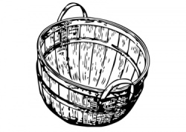Write in, on, near, under in the gaps

1. The mangoes are …………………the basket.



1. The millet is …………….the chair.



1. The fish is ………………..the water
2. The beans are ………….the cassava
3. The peas are ………the mat.

|  |  |  |  |  |
| --- | --- | --- | --- | --- |
| **Date** | **Subject** | **Class** | **Time** | **No. of pupils** |
|  |  |  |  |  |

**THEME : Food and Nutrition**

**SUBTHEME : Names of food**

**CONTENT : Use of that / those**

That is a bird.

Those are birds

**EXERCISE :**

**Fill in the gaps using That / Those.**

1. ____________________is a tree.

2. _______________________are trees.

3. _______________________is a bell.

4. _____________________are pencils.

5. ________________________is a table.

|  |  |  |  |  |
| --- | --- | --- | --- | --- |
| **Date** | **Subject** | **Class** | **Time** | **No. of pupils** |
|  |  |  |  |  |

**THEME : Food and Nutrition**

**SUBTHEME :**

**CONTENT :**

**Use of this / these**

**Examples**

This is a table.

These are tables.

**EXERCISE**  :

**Make correct sentences using This/These correctly.**

1. 





|  |  |  |  |  |
| --- | --- | --- | --- | --- |
| **Date** | **Subject** | **Class** | **Time** | **No. of pupils** |
|  |  |  |  |  |

**THEME : Food and Nutrition**

**SUBTHEME :**

**CONTENT : occupation**

**People and their work**

Doctor - treats sick people

Teacher - teaches pupils

Lawyer - Solves cases in the court

Nurse - cares for the sick

Policeman - keeps law and order

Cook - cooks food

Tailor - sews clothes

Cobbler - mends shoes.

Tinker - repairs pots

Carpenter -

Dentist - treats teeth

Optician - treats eyes

**Exercise**

**Match people and their occupation.**

Doctor treats teeth

Nurse care for the sick

Optician treats our teeth

Dentist cooks food

Cook treats sick people

|  |  |  |  |  |
| --- | --- | --- | --- | --- |
| **Date** | **Subject** | **Class** | **Time** | **No. of pupils** |
|  |  |  |  |  |

**THEME : Food and Nutrition**

**SUBTHEME :**

**CONTENT :**

**Alphabetical**

a b c d e f g h i j k l

n o p q r s t u v w x y z

knife, rake, axe, hoe

mat, hat, net, eggs

eggs, hat, mat, net

**Activity**

1. Arrange the following in A B C order.

d c b a

____________________________________________

s r q p

____________________________________________

rat, boy, girl, aunt

____________________________________________

umbrella, tin, vest, stick

____________________________________________

hoe, axe, cut, bed

____________________________________________

|  |  |  |  |  |
| --- | --- | --- | --- | --- |
| **Date** | **Subject** | **Class** | **Time** | **No. of pupils** |
|  |  |  |  |  |

**THEME : Food and Nutrition**

**SUBTHEME :**

**CONTENT :**

**Homophones**

These are words of the same sound but different meaning.

**Example**

to – two – too

cat – cut

heart – hurt

bad – bird – bud

mad – mud

hat – hut

son – sun

**fill in with the correct word**

1. Tom is going ______________ school ( two, to, too)
2. The ____________ is flying over the tree. (bad, bird, bud)
3. Grace is wearing a _____________. (hat, hut)
4. I have __________ my leg. (hurt, heart)
5. Sarah has drawn a _____________ . (cat, cut)
6. I saw a ____________ man. (mad, mud0
7. The ____________ is very hot today. (son, sun)
8. The __________ of two and two is four. ( sum, sam)

|  |  |  |  |  |
| --- | --- | --- | --- | --- |
| **Date** | **Subject** | **Class** | **Time** | **No. of pupils** |
|  |  |  |  |  |

**THEME : Food and Nutrition**

**SUBTHEME :**

**CONTENT : Conjuctions**

Using …………. and …………..

Examples

1. She is eating an orange. She is eating an apple.

She is eating an orange and an apple.

1. My father has a car. He has a bicycle.

My father has a car and a bicycle

1. Peter is a boy. John is also a boy.

Peter and John are boys.

**Exercise**

**Join these sentences using ……… and ………..**

1. Ivan has a book. He has a pencil.
2. The doctor is eating chicken. The doctor is eating chips.
3. The dentist has a bag. He has a thermometer.
4. The farmer has a spade. He has a panga.
5. The teacher has a stick. He has a pen.

|  |  |  |  |  |
| --- | --- | --- | --- | --- |
| **Date** | **Subject** | **Class** | **Time** | **No. of pupils** |
|  |  |  |  |  |

**THEME : Food and Nutrition**

**SUBTHEME :**

**CONTENT :**

Using …………. but …………..

**Examples**

1. It rained heavily. I did not plant crops.

It rained heavily but I did not plant crops.

1. I am sick. I will not go to the hospital.

I am sick but I will not go to the hospital.

**Exercise**

1. I am hungry. I do not want food.
2. My father has a car. He doesn’t drive it.
3. I feel cold. I don’t have a sweater.
4. He rang the bell. I did not hear.
5. The farmer grows crops. He doesn’t have food.

|  |  |  |  |  |
| --- | --- | --- | --- | --- |
| **Date** | **Subject** | **Class** | **Time** | **No. of pupils** |
|  |  |  |  |  |

**THEME : Food and Nutrition**

**SUBTHEME :**

**CONTENT :**

Using …………. because …………..

**Examples**

1. I came late. I was sick

I came late because I was sick.

1. They are dirty. They did not bathe.

They are dirty because they did not bathe.

**Exercise**

**Join these sentences using ……….. because…………**

1. My mother did not cook food. She did not have money.
2. The cobbler is crying. He lost his money.
3. The nurse is tried. She worked the whole night.
4. My father bought a panga. He wanted to cut the tree.
5. Our knife is not cutting. It is blunt.

|  |  |  |  |  |
| --- | --- | --- | --- | --- |
| **Date** | **Subject** | **Class** | **Time** | **No. of pupils** |
|  |  |  |  |  |

**THEME : Food and Nutrition**

**SUBTHEME :**

**CONTENT :**

Using …………. than …………..

**Examples**

1. My aunt is taller. My uncle is tall.

My aunt is taller than mu uncle.

1. A monkey is big. A lion is bigger.

A lion is bigger than a monkey.

**Exercise**

**Join using ………. than………..**

1. A rat is smaller. A rabbit is small.
2. A lion is tougher. An elephant is tough.
3. My mother is fatter. My father is fat.
4. A bus is bigger. A taxi is big.
5. Our cousin is browner. Our nephew is brown.
6. The tea is hotter. The porridge is hotter.
7. The water was colder. The ice was colder.
8. My dress is welter. My blanket is wet.

**P.1 COMPOSITION LESSON NOTES FOR TERM II 2017**

|  |  |  |  |  |
| --- | --- | --- | --- | --- |
| **Date** | **Subject** | **Class** | **Time** | **No. of pupils** |
|  |  |  |  |  |

**THEME : Weather**

**SUBTHEME : Element of weather**

**COMPETENCES : Identifying the elements of weather**

**: Naming and describing them**

**: Answering the questions given.**

**CONTENT : Vocabulary**

*Elements of weather are the things that show change in weather.*

sun clouds rain sunshine wind cover

***Common words***

*blow, hot, water, wet, shine, shining, raining, blowing, covering*

**Exercise**

**Make correct sentences using these words**

1. Sun (b) Rain (c) Clouds (d) Wind

|  |  |  |  |  |
| --- | --- | --- | --- | --- |
| **Date** | **Subject** | **Class** | **Time** | **No. of pupils** |
|  |  |  |  |  |

**THEME : Weather**

**SUBTHEME : Types of weather**

**COMPETENCES : Reading the given vocabulary**

**: Spell them correctly**

**: Use them to construct sentences correctly.**

**CONTENT : Vocabulary**

sunny rainy windy cloudy raining, shinning

**Structure**

* ***What is the weather like?***
* ***Is it ___?***

1. 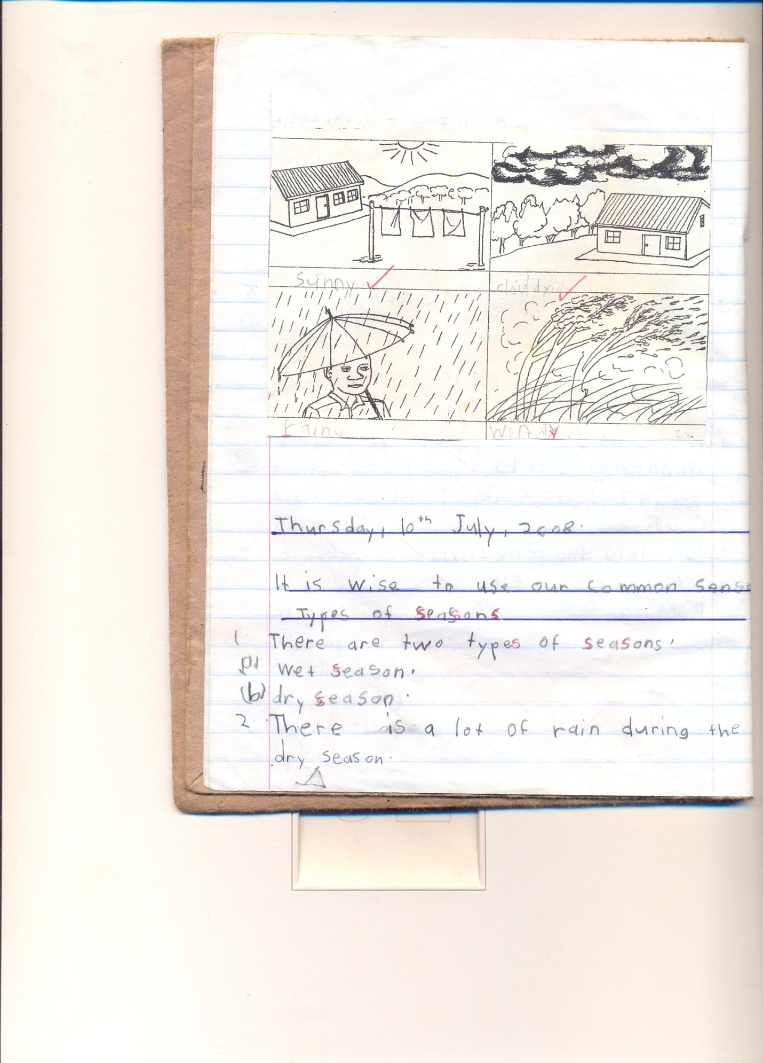What is the weather now?

The weather is ________now.

*Is it raining?*

*Yes, it is*

*No, it is not*

1. 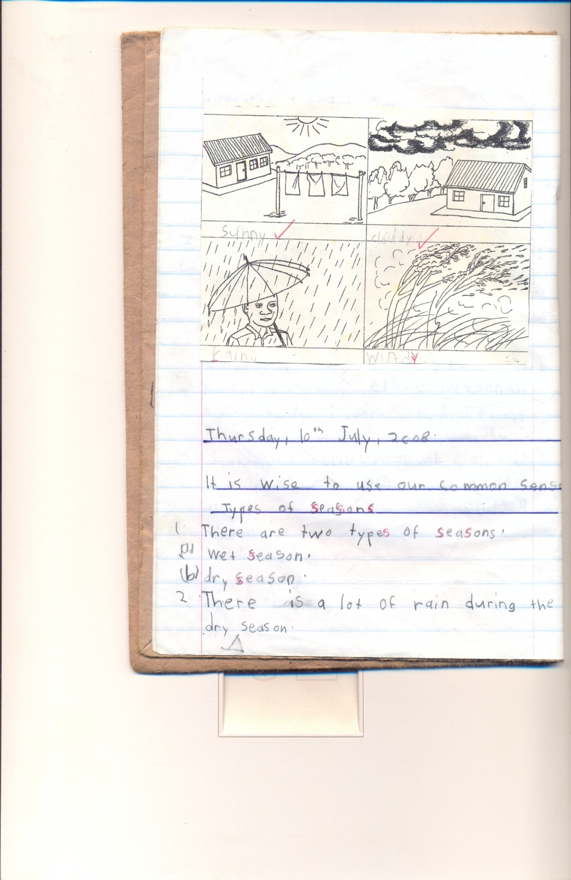What is the weather today?

The weather is ____today.

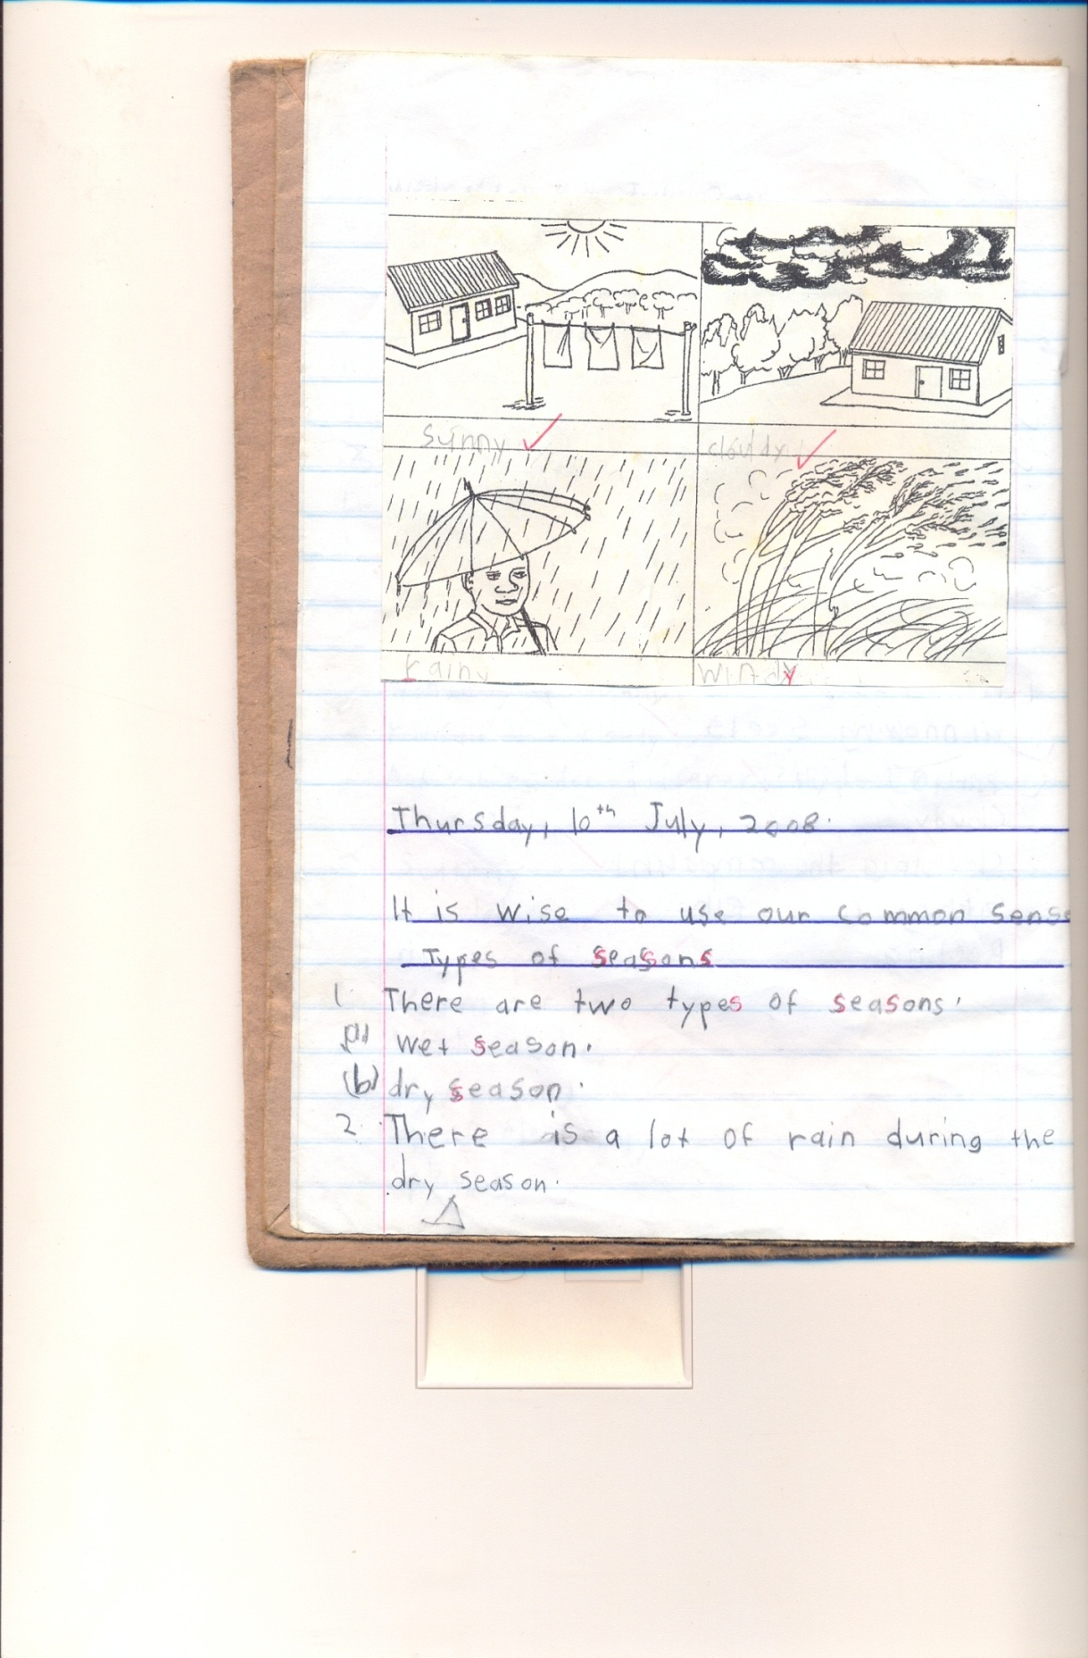

The weather was____ yesterday.



The weather now is ___________

|  |  |  |  |  |
| --- | --- | --- | --- | --- |
| **Date** | **Subject** | **Class** | **Time** | **No. of pupils** |
|  |  |  |  |  |

**THEME : Weather**

**SUBTHEME : Types of weather**

**COMPETENCES : Reading the word / sentences correctly.**

**: Constructing sentences from the table.**

**Use of is, isn’t**

**A substitution table**

|  |  |  |  |
| --- | --- | --- | --- |
| The weather | is  isn’t | windy  cloudy  sunny  rainy | now |

**Examples**

1. The weather is windy now.
2. The weather isn’t cloudy now.
3. The weather is sunny now.
4. The weather isn’t rainy now.

**Exercise**

Write six sentences using words in the table.

|  |  |  |  |  |
| --- | --- | --- | --- | --- |
| **Date** | **Subject** | **Class** | **Time** | **No. of pupils** |
|  |  |  |  |  |

**THEME : Weather**

**SUBTHEME : Activities for different seasons (Garden tools)**

**COMPETENCES : Reading vocabulary related to tools**

**: Spell the letters in the vocabulary**

**: Answer questions related to the given vocabulary.**

**CONTENT : Vocabulary (garden tools)**

axe, wheelbarrow , hoe , knife, watering can , rake , basket, slasher , spade

exercise

* 1. Fill in the missing letters

a____e, wh__ __lbarrow, kn__fe, h__e

* 1. Read and draw

Hoe __________ basket __________ axe ______ slasher _______

* 1. 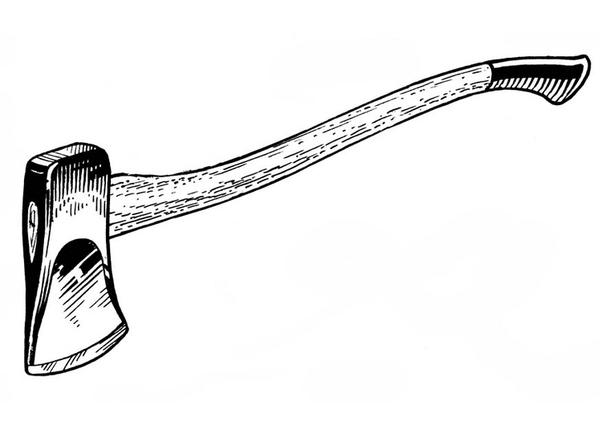Name these pictures.





|  |  |  |  |  |
| --- | --- | --- | --- | --- |
| **Date** | **Subject** | **Class** | **Time** | **No. of pupils** |
|  |  |  |  |  |

**THEME : Weather**

**SUBTHEME : Activities for different seasons (Garden tools)**

**COMPETENCES : Reading vocabulary related to tools**

**: Spell the letters in the vocabulary**

**: Answer questions related to the given vocabulary.**

**CONTENT : Vocabulary( uses of garden tools)**

**Structure**

**What is this / what do we use __________ for**



**Activity**

**Match garden tools to their uses**

**Uses of different garden tools.**

Garden tool use

axe digging

hoe cutting small trees

watering can watering plants

|  |  |  |  |  |
| --- | --- | --- | --- | --- |
| **Date** | **Subject** | **Class** | **Time** | **No. of pupils** |
|  |  |  |  |  |

**THEME : Weather**

**SUBTHEME : Activities for different seasons**

**COMPETENCES : Reading the given vocabulary**

**: Read the given tools in plurals**

**: Identify the garden tools**

**: Answering questions correctly**

**CONTENT : Vocabulary**

axe wheelbarrow hoe rake

knife slasher spade basket

**Structure**

1. What do we use ___________________for?
2. We use a hoe for _____________
3. We use a knife for _____________

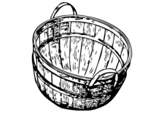

1. We use a basket for _____________

(digging, carrying, cutting)

**Make correct sentences using these words**

* + - * 1. Carrying
        2. Digging
        3. Cutting

1. Fill in correctly
2. We use a _________________ for watering plants
3. A _________________ is used for carrying things.
4. A_____________________ is used for slashing.
5. We use a __________________ for digging.

|  |  |  |  |  |
| --- | --- | --- | --- | --- |
| ***Date*** | ***Subject*** | ***Class*** | ***Time*** | ***No. of pupils*** |
|  |  |  |  |  |

***THEME : Weather***

***SUBTHEME : Activities done in different seasons (clearing, weeding, watering, plunning, harvesting)***

***COMPETENCES :***

***CONTENT : Structure***

*Is he/ she?*

*No, he / she is not __*

*Yes he/ she is ____*

*Picture A*

*Clearing the garden Is she planting?*

*__________________*

*Picture B*

*Planting Is he weeding ?*

*__________________*

*Picture C*

*Weeding Is she plunning ?*

*__________________*

*Picture D*

*Harvesting crops Is he/ she watering?*

*__________________*

|  |  |  |  |  |
| --- | --- | --- | --- | --- |
| ***Date*** | ***Subject*** | ***Class*** | ***Time*** | ***No. of pupils*** |
|  |  |  |  |  |

***THEME : Weather***

***SUBTHEME : Activities done in different seasons***

***COMPETENCES :***

***CONTENT : Types of seasons***

***Vocabulary***

*wet, dry, rain, sunshine, clouds, umbrella, gumboots, sweater, jacket, hat. Raincoat, hot, cold, season*

***Make sentences using these words***

* 1. *a) hat –*

*b) Hut –*

* 1. *a) sweater –*

*b) Sweat –*

***Choose the correct word from the brackets to complete correctly.***

1. *Farmers grow crops in the ___season. (wet, rain)*
2. *I am putting a __because it is sunny. (hut, hat)*
3. *I put on a sweater when it is __. (hot, cold)*

***Re-arrange these words correctly***

*etw_________, ryd________, ainr____________,*

|  |  |  |  |  |
| --- | --- | --- | --- | --- |
| **Date** | **Subject** | **Class** | **Time** | **No. of pupils** |
|  |  |  |  |  |

**THEME : Weather**

**SUBTHEME : Effects and management of weather**

**COMPETENCES : Read the given vocabulary**

**: Spell and pronounce them correctly**

**: Vocabulary**

**: Jacket, gumboot, cap, hat, vest, umbrella, blanket, sweater,**

**socks, raincoat, shirt, dress, shorts.**

**CONTENT : Structure**

**What is this?**

This is a hat .

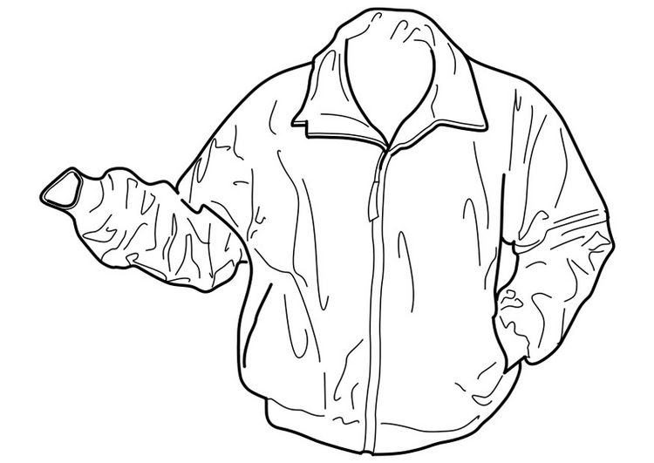



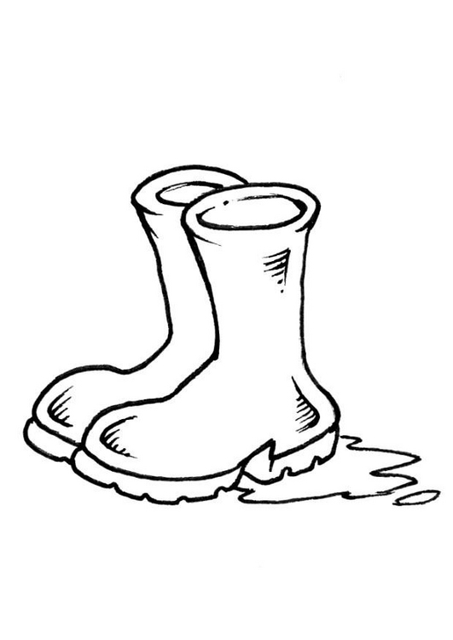

**EXERCISE**

**Make correct sentences using these given words**

1. Umbrella
2. Hat
3. Jacket

**Get a small word from the big word**

1. Blanket
2. Sweater
3. Rain coat
4. Hat
5. Gumboots

Children will do the exercise on page MK English book 1.

|  |  |  |  |  |
| --- | --- | --- | --- | --- |
| **Date** | **Subject** | **Class** | **Time** | **No. of pupils** |
|  |  |  |  |  |

**THEME : Weather**

**SUBTHEME : Activities for different seasons**

**COMPETENCES : Reading the guided composition correctly**

**: Identifying new vocabulary**

**: Filling in the correct words**

**CONTENT : Guided composition about ourfamily**

**Our Family**

We are …………….members in our family. During the …………..weather. We wear gumboots,……………………and ……………….to get wet. In the……………weather, it is always so ……….., we ……………under the………….. to get shade while doing work.

(umbrellas, hot, four, sunny, rainy, sit, rain coats, tree)

|  |  |  |  |  |
| --- | --- | --- | --- | --- |
| **Date** | **Subject** | **Class** | **Time** | **No. of pupils** |
|  |  |  |  |  |

**THEME : Weather**

**SUBTHEME : Effects and management of weather**

**COMPETENCES : Read the colour names correctly**

**: Pronounce and spell them correctly**

**: Use them with given structures correctly**

**CONTENT : Colours**

black blue white red green

yellow brown

**What colour is this?**

1. It is a ……………………… sweater.

2. This is a …………………… hat

**Read, draw and shade**

|  |  |  |
| --- | --- | --- |
| Yellow socks | Green jacket | Black gumboots |
|  |  |  |

**LESSON**

Write a short story about “A rainy Day”

**Use yes, it is / no, it is not in the given exercise**

|  |  |  |  |  |
| --- | --- | --- | --- | --- |
| **Date** | **Subject** | **Class** | **Time** | **No. of pupils** |
|  |  |  |  |  |

**THEME : Accident and safety**

**SUBTHEME : Things that cause Accidents at home**

**COMPETENCES : Reading the given vocabulary correctly**

**: Pronounce the given vocabulary correctly**

**: Spell the given vocabulary correctly**

**CONTENT : Vocabulary**

pin knife fire razorblade

thorn snake broken bottles

needle safety pin stone

**Structure**

What is this/that?

This is a _____________

This is a ______________

This is a ______________

**Make sentences using these words**

1. Razorblade
2. Knife
3. Snake

**Jumbled composition**

**Arrange these sentences to make a good story**

* 1. Like needles, broken bottles, razorblades and pins.
  2. Kintu likes playing with sharp things.
  3. It cut his finger.
  4. One day he picked a razorblade
  5. He now fears sharp objects.

|  |  |  |  |  |
| --- | --- | --- | --- | --- |
| **Date** | **Subject** | **Class** | **Time** | **No. of pupils** |
|  |  |  |  |  |

**THEME : Accidents and safety**

**SUBTHEME : Accidents at home**

**COMPETENCES : Telling a story about an accident**

**: Children re-telling the story**

**: Reading the vocabulary related to accident**

**: Answering questions correctly**

**: Vocabulary**

burns hurt bites falls cuts near drowning

**CONTENT : Structure**

* Do not climb trees, you will _____down.
* Do not play with sharp things they will ____you.
* Do not play at the rubbish pit the broken bottles / glasses an ____you.
* Never play with stones, you will _______yourself.
* Do not play in water you will __________

|  |  |  |  |  |
| --- | --- | --- | --- | --- |
| **Date** | **Subject** | **Class** | **Time** | **No. of pupils** |
|  |  |  |  |  |

**THEME : Accidents and safety**

**SUBTHEME : Accidents and safety at home.**

**COMPETENCES : Interpret the pictures**

**: Write sentences related to the theme.**

**CONTENT : Guided picture composition**

What is happening?

|  |  |  |  |
| --- | --- | --- | --- |
| **1. falls** | **2. cuts** | **3. near drowning** | **4. burns** |
|  |  |  |  |

1. The boy is falling off from the tree.
2. Mary is cutting herself.
3. Kato is drowning.
4. The baby is playing with fire.

**Use the same pictures to construct sentences**

**____________________________________________________________________________________________________________________________________________________________________________________________________________________________________________________________**

|  |  |  |  |  |
| --- | --- | --- | --- | --- |
| **Date** | **Subject** | **Class** | **Time** | **No. of pupils** |
|  |  |  |  |  |

**THEME : Living together**

**SUBTHEME : The family**

**COMPETENCES : Read the given vocabulary**

**: Spell and pronounce the words correctly**

**: Answer the given structures**

**CONTENT : Vocabulary**

father , mother, sister, brother, *family, extended*, nuclear, baby, uncle, aunt, nephew, niece grandfather , grandmother

Who is this / These?

**Write the opposites of these words**

Mother

Brother

Niece

Grandmother

**Make sentences using these words**

Mother

Brother

Father

|  |  |  |  |  |
| --- | --- | --- | --- | --- |
| ***Date*** | ***Subject*** | ***Class*** | ***Time*** | ***No. of pupils*** |
|  |  |  |  |  |

***THEME : Living together***

***SUBTHEME : Needs of a family***

***COMPETENCES :***

***CONTENT : Vocabulary***

*Shelter, water,, food, medical care, clothes, security, education, money*

*Make sentences using these words*

1. Food –
2. Foot -

|  |  |  |  |  |
| --- | --- | --- | --- | --- |
| **Date** | **Subject** | **Class** | **Time** | **No. of pupils** |
|  |  |  |  |  |

**THEME : Living together**

**SUBTHEME : Ways of living together at school**

**COMPETENCES : Reading the vocabulary about school**

**: Use them to answer the structure correctly.**

**CONTENT : Vocabulary**

playing sharing caring working

play share care work etc.

**Structure**

What are they / you doing?

I am playing with a ball.

We are sharing

They are working on the farm

(Pictures to be drawn)

**Complete the sentences correctly**

1. Musa is ___the blackboard (clean)
2. Pastor is _____for people (pray)
3. We are _______mangoes (share)
4. They are _____together (work)

**Make sentences using these words**

1. Playing
2. Praying

|  |  |  |  |  |
| --- | --- | --- | --- | --- |
| ***Date*** | ***Subject*** | ***Class*** | ***Time*** | ***No. of pupils*** |
|  |  |  |  |  |

***THEME : Living together***

***SUBTHEME : Working together in a community***

***COMPETENCES :***

***CONTENT : Free composition writing***

***(our family/ my family)***

|  |  |  |  |  |
| --- | --- | --- | --- | --- |
| **Date** | **Subject** | **Class** | **Time** | **No. of pupils** |
|  |  |  |  |  |

**THEME : Food and Nutrition**

**SUBTHEME : Names of common foods**

**COMPETENCES : Identifying the common foods**

**: Read the names of foods**

**: Use and answer the structure correctly**

**CONTENT : Vocabulary**

banana fish eggs cassava yam

beans potatoes Irish potatoes potatoes

**Structure**

**EXERCISE**

What food is this / these?

 These are



These are

 This is a

2. Re-arrange words to make a good sentence.

a) eating cassava and fish . I like

yams in our garden. We have

eats an egg every day. Our baby

|  |  |  |  |  |
| --- | --- | --- | --- | --- |
| **Date** | **Subject** | **Class** | **Time** | **No. of pupils** |
|  |  |  |  |  |

**THEME : Food and Nutrition**

**SUBTHEME : Names of common foods**

**COMPETENCES : Identifying the common foods**

**: Reading food names**

**: Answering structures correctly**

**CONTENT : How many ……..are there?**

 There are ____eggs.

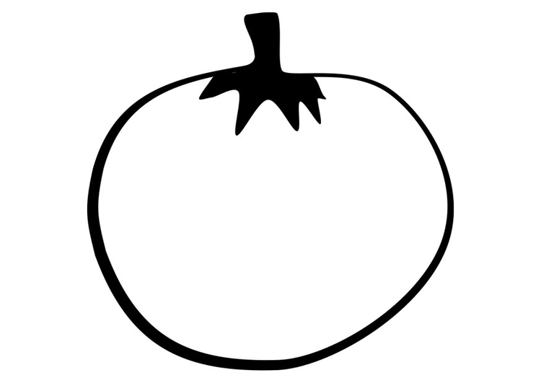

 These are _________tomatoes.

There are _____________fish



There are _____________ beans.

Children will do the exercise on __________MK book 1

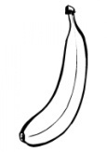**Make correct sentences from the given pictures**



|  |  |  |  |  |
| --- | --- | --- | --- | --- |
| **Date** | **Subject** | **Class** | **Time** | **No. of pupils** |
|  |  |  |  |  |

**THEME : Food and Nutrition**

**SUBTHEME : Names of foods and their sources**

**COMPETENCES : Reading the words correctly**

**: Identifying the sources of food.**

**: Completing the structure correctly**

**CONTENT : Sources of food**

shops market river lakes

gardens farm

**Structures**

**Where do we get ____from?**

We get fish from_______.

We get meat from the_____________________.

We buy tomatoes from the ________________

We get milk from the ______________

**Arrange these sentences and make a good story**

1. She carries a hoe and a basket.
2. When food is ready
3. Mother goes to the garden
4. Mother calls us to eat
5. She brings cassava and potatoes

|  |  |  |  |  |
| --- | --- | --- | --- | --- |
| **Date** | **Subject** | **Class** | **Time** | **No. of pupils** |
|  |  |  |  |  |

**THEME : Food and nutrition**

**SUBTHEME : Names of food**

**COMPETENCES : Reading the words and sentences correctly**

**CONTENT : Likes and Dislikes.**

**Structure**

Do you like matooke?

Yes, I do. / No, I don’t.

**Exercise**

Do you like rice?

No,…………………………

Yes,…………………………..

Do you like meat?

Yes,………………………….

No,……………………………

**Circle the words from the puzzle and colour**

1. yam , rice, meat, eggs, farm, shop,

2. garden, hen

|  |  |  |  |  |  |  |  |
| --- | --- | --- | --- | --- | --- | --- | --- |
| y | b | f | m | e | a | t | k |
| a | v | z | n | s | t | o | l |
| m | o | s | y | h | g | m | i |
| g | v | w | s | o | a | a | s |
| m | i | l | k | p | r | r | f |
| x | h | e | n | r | d | k | a |
| r | i | c | e | n | e | e | r |
| w | a | r | e | r | n | t | m |

|  |  |  |  |  |
| --- | --- | --- | --- | --- |
| **Date** | **Subject** | **Class** | **Time** | **No. of pupils** |
|  |  |  |  |  |

**THEME : Food and Nutrition**

**SUBTHEME : Uses of food**

**CONTENT : Guided composition**

**Food & Nutrition**

**Guided composition**

**OUR FARM**

My father is a farmer. He does a lot of work on the farm. On the farm I see many animals. The herdsmen cut good grass for the animals.

He gets every day.

My mother looks after ________________________________

Mother grows ____________________

______________and _______________

In her garden. The farm gives us food we eat, we also sell the food from the farm and get money. This money is used for paying our school fees, buying clothes and other family needs.

**Lesson: content: free writing**

**Write a short story about “The Food I like”**

**P.1COMPREHENSION LESSON NOTES FOR TERM II 2017**

|  |  |  |  |  |
| --- | --- | --- | --- | --- |
| **Date** | **Time** | **Class** | **Pupils** | **Subject** |
|  |  |  |  | **Comprehension** |

**Theme : Weather**

**Content :**

**Elements of weather**

* **Reading the short passage**
* **Identify new vocabulary**
* **Answer questions correctly related to the structures**

***Mary the Good Girl***

***Mary is six years old. She goes to Cornerstone Junior School. When it rains, she uses an umbrella and gum boots to go to school. When the weather is windy, she wears a sweater to feel warm. Mary likes playing with a kite when the wind is blowing.***

***Questions***

1. ***What is the story about?***
2. ***Which school does Mary go to?***
3. ***How old is Mary?***
4. ***What does she use when the weather is rainy?***
5. ***Draw an umbrella and gum boots***



|  |  |  |  |  |
| --- | --- | --- | --- | --- |
| **Date** | **Time** | **Class** | **Pupils** | **Subject** |
|  |  |  |  | **Comprehension** |

**Theme : Weather**

**Content :**

**Elements of weather**

* Read the dialogue correctly
* Pronounce the words correctly
* Act the dialogue and answer the given questions

**Dialogue about elements of weather**

Wamala : Good morning Duku?

Duku : Good morning Wamala.

Wamala : Why have you come late?

Duku : It has been raining since morning.

Wamala : Why didn’t you use an umbrella

Duku : I did not have any/ one

Wamala : My mother bought for me an umbrella and gum boots last week.

Duku : I will also tell my mother to buy for me too.

Wamala : Bye Bye

Duku : Good bye

**Questions**

1. ***How many people are talking in the conversation.***
2. Who are the people in the conversation?
3. Who came late?
4. Why did Duku come late?
5. How many people are in the conversation?
6. Mention any three things we use during a rainy day

|  |  |  |  |  |
| --- | --- | --- | --- | --- |
| **Date** | **Time** | **Class** | **Pupils** | **Subject** |
|  |  |  |  | **Comprehension** |

**Theme : Weather**

**Content :**

**Types of weather**

* **Read the given poem**
* **Reads and pronounce the words correctly**
* **Move according to the rhyme.**

***Read the poem below and answer the questions that follow***

***Rainy weather***

***Rain Rain Rain***

*Rain gives us water*

*Water for cooking, bathing, washing and drinking*

*On a Rainy day,*

*We put on rain coats,*

*We also use umbrellas and gumboots*

*I like rain*

*By Richard*

***Questions.***

1. *What is the poem about?*
2. *How many stanzas has the poem?*
3. *What does the rain give us?*
4. *Write the Title of the story?*
5. *Who wrote the poem?*
6. *Give two uses of water.*

|  |  |  |  |  |
| --- | --- | --- | --- | --- |
| **Date** | **Time** | **Class** | **Pupils** | **Subject** |
|  |  |  |  | **Comprehension** |

**Theme : Accident and Safety**

**Content : *Prevention of accidents at home***

**Accident and safety at home / school**

* Read the poem correctly
* Recite the poem and pronounce the words correctly.

**Poem about accident**

**Accident Accident**

We are fed up with you

At home, accidents!

On the way, accidents!

Over speeding, accidents!

Electric wires, accidents!

Oh! Do not take our lives anymore.

***By Tom Holland***

**Questions**

1. What is the poem about?
2. Name any two places where accidents happen?
3. What can cause accidents?
4. Have you ever had an accident?
5. ***Who wrote the poem?***
6. ***How many lines are in the poem?***

|  |  |  |  |  |
| --- | --- | --- | --- | --- |
| **Date** | **Time** | **Class** | **Pupils** | **Subject** |
|  |  |  |  | **Comprehension** |

**Theme : Living together**

**Content :**

**The family members**

**My Family**

My name is Kabega. My father is Mr. Kiwanuka and my mother is Mrs. Kiwanuka. I have two sisters Nakato and Babirye. My sisters are younger than me. They are twins. I have an older brother. My uncle Charles and Aunt Mable are kind.

My sisters sweep the compound and I also go to fetch water from the well.

I love my family so much

**Questions**

1. What is the name of the boy?
2. Who are Kabega’s sisters?
3. How many sisters does he have?
4. What is the name of his uncle?
5. What is the name of his auntie?
6. Draw Kabega’s family.

|  |  |  |  |  |
| --- | --- | --- | --- | --- |
| **Date** | **Time** | **Class** | **Pupils** | **Subject** |
|  |  |  |  | **Comprehension** |

**Theme : Living together**

**Content :**

**Ways of living together**

* **Read the conversation**
* **Act the conversation**

**Dialogue about family**

Mark : Hullo Mathew

Mathew : Hullo Mark

Mark : How are your family members?

Mathew : They are fine except my little sister Amanda who is sick

Mark : Oh! Sorry, has your mother given her medicine?

Mathew : No, my father has taken her to the hospital

Mark : I wish her quick recovery. Goodbye

Mathew : Good bye too.

**Questions**

1. Who are the people talking in the dialogue?
2. Whose sister is sick?
3. Was Matthew’s sister given medicine?
4. How many people are talking in the dialogue?

|  |  |  |  |  |
| --- | --- | --- | --- | --- |
| ***Date*** | ***Time*** | ***Class*** | ***Pupils*** | ***Subject*** |
|  |  |  |  | ***Comprehension*** |

***Theme : Living together***

***Content : Working together in a community***

|  |  |  |  |  |
| --- | --- | --- | --- | --- |
| **Date** | **Time** | **Class** | **Pupils** | **Subject** |
|  |  |  |  | **Comprehension** |

**Theme : Food and Nutrition**

**Content :**

**Different names of food.**

**SHOPPING**

|  |  |  |
| --- | --- | --- |
| **Items** | **Quantity** | **Price** |
| Tamato  Sugar  Cabbage  Mango  Fish | 1  Kg  1  1  1 | 100/=  200/=  300/=  100/=  50/= |

**Questions**

1. How much is 1 kg of sugar?
2. How much does a tomato cost?
3. What is the price of 1 fish?
4. How much will Mary pay to buy a mango and 1kg of sugar?
5. How much money will Mary pay altogether?
6. Which item is expensive?

**GRAMMAR REVISION**

**CONTENT : Use of “is” and “are”**

“Is” is used for one object

“Are” is used for many.

**Fill in the gaps with is / are correctly.**

1. This is my teacher.
2. The boys are playing football.
3. These _______________________girls.
4. Those _______________________boys
5. David _____________________going to school.
6. The teacher ____________________teaching children.
7. The cats____________________playing.
8. Tom and Sarah ____________________friends.
9. Today ______________________Friday.
10. It _____________________getting late.

**CONTENT : Use of has / have.**

Have is used for many.

Has is used for one.

**Examples**

1. He has a bicycle
2. They have nice glasses

We He

You have She has

I It

They

**EXERCISE**

**Write has/ have correctly.**

1. I ____________________________five shillings.
2. Birds _________________________two wings.
3. You ______________________________my pencil.
4. She________________________________ a nice dress.
5. He _______________________________ many books.
6. We ______________________________ a nice teacher.
7. An insect ________________________________ three parts.
8. *The sky __________dark clouds.*
9. *My mother ____two pineapples.*
10. *Jane __one brother*
11. *My uncle __two cars*
12. *Tom and john __nice flowers*
13. *I __three dresses.*

|  |  |  |  |  |
| --- | --- | --- | --- | --- |
| **Date** | **Time** | **Class** | **Pupils** | **Subject** |
|  |  |  |  | **Comprehension** |

**Theme : A Dialogue about food**

**Content :**

**Ali:**  Hullo Ryan

**Ryan:**  Hullo Ali

**Ali:**  Did you eat supper?

**Ryan:**  Yes, I did

**Ali:**  What type of food did you eat?

**Ryan:**  I ate rice, fish and potatoes

**Ali:**  What about you?

**Ryan:**  Oh! My dear I ate posho, irish- potatoes, meat and greens

**Ali:**  Ha! Ha! Ha! Won’t you fall sick?

**Ryan:** No, that is what we call balanced diet

**Questions**

1. How many people are talking in the dialogue?
2. What is the dialogue about?
3. Give three examples of food mentioned in the dialogue
4. Who are the people talking in the dialogue
5. Draw these

|  |  |  |  |
| --- | --- | --- | --- |
|  |  |  |  |
| fish | potatoes | rice | meat |

|  |  |  |  |  |
| --- | --- | --- | --- | --- |
| **Date** | **Time** | **Class** | **Pupils** | **Subject** |
|  |  |  |  | **Comprehension** |

**Theme :**

**Content : a rhyme about occupation**

I thought about a teacher

Who teaches pupils at school

I thought about a doctor

Who treats patients in the hospital

I thought about a framer who grows crops and keeps animals

I thought about a carpenter who makes furniture for us

I thought about a driver who drives the school van

**Questions**

1. What is the rhyme about?
2. Who teaches pupils at school?
3. Where do we go when we are sick?
4. Why is a farmer important in the community?
5. What is the role of a doctor?
6. What do the following people do?

Head teacher: _________________________

Secretary: ____________________________

Librarian: ____________________________

Bursar: _____________________________

|  |  |  |  |  |
| --- | --- | --- | --- | --- |
| **Date** | **Time** | **Class** | **Pupils** | **Subject** |
|  |  |  |  | **Comprehension** |

**Theme :**

**Content : a rhyme about food**

**Food Food Food**

Mummy and daddy are there for us

Daddy buys food and mummy prepares

To look strong, healthy and happy

We need to eat all classes of food

Without food you cannot stand

**Questions**

1. Write the title of the rhyme.
2. Who buys food at home?
3. _________ cooks food at home.
4. What is the story about?
5. Give the opposite of the following words
6. happy ____________________
7. healthy____________________
8. stand ____________________
9. strong ____________________
10. buy ____________________

|  |  |  |  |  |
| --- | --- | --- | --- | --- |
| **Date** | **Time** | **Class** | **Pupils** | **Subject** |
|  |  |  |  | **Comprehension** |

**Theme :**

**Content : a story about the farm**

**The farm**

Mr. Mutale is a farmer. His farm is found at Katalemwa in Wakiso district. On his farm he keeps animals like goats, sheep and cows.

He grows matoke, cassava, sweet potatoes and tomatoes. He serves many markets in Uganda. Mr. Mutale is a rich man.

**Questions**

1. what is the title of the story?
2. Who is the owner of the farm?
3. In which district do we find Mr. Mutate’s farm?
4. Give two examples of food which Mr. Mutale grows on his farm
5. Write the opposite of the words below

man __________________

rich ___________________

like ____________________

1. Draw Mr. Mukasa digging in the garden

|  |  |  |  |  |
| --- | --- | --- | --- | --- |
| **Date** | **Time** | **Class** | **Pupils** | **Subject** |
|  |  |  |  | **Comprehension** |

**Theme :**

**Content : puzzle**

**Circle the words given from the puzzle**

yam meat market garden farm den

hen shop war knee rice milk

|  |  |  |  |  |  |  |  |
| --- | --- | --- | --- | --- | --- | --- | --- |
| y | b | f | m | E | a | t | k |
| a | v | z | n | S | t | o | l |
| m | o | s | y | H | g | m | i |
| g | v | w | s | O | a | a | s |
| m | i | l | k | P | r | r | f |
| x | h | e | n | R | d | k | a |
| r | i | c | e | N | e | e | r |
| w | a | r | e | R | n | t | m |

**COMPOSITION REVISION**

**Competences : Sentence construction using the given words**

* cooking
* praying
* playing
* working
* cleaning
* sweeping
* learning
* singing
* shading

**Make sentences using these words**

1. Cooking 3. Praying
2. Playing 4. Learning

**Complete these sentences using the word in brackets**

1. The boys are ………….foot ball.(play)
2. Ali is …….the house (clean)
3. Mother is…………..food (cook)
4. Mary *is ……….the compound (sweep)*
5. *The brothers are ……..pictures. (shade)*

**HOME WORK**

**CONTENT : Guided picture composition**

Every Monday, ___________ Wednesday_______ Friday, I walk to

___________________________________

I go with my  __________________________________.

She helps me to cross the ___________________. The road is

busy all the time. There are many   _____________________

and many  _____________________________.



When I reach school, I sit on the _____________________and I read

my __________________________.

(road , mother , cars , bicycle, chair, books , Thursday, school , Tuesday)

**COMPREHENSION HOME WORK**

***Content: Seasons***

*There are two types of seasons. The wet season and the dry season.*

*Farmers grow crops like beans, sweet potatoes and cassava during the wet season.*

*In the dry season, they harvest the ready crops for eating and selling. They use baskets to carry them from the Gardens to market.*

***Questions***

1. *How many seasons do we have? ---------------- and -----------------*
2. *In which season do farmers grow crops?*
3. *Write the title of the story.*
4. *What do farmers use to carry ready crops?*
5. *Name two crops mentioned in the story.*

**PASSAGE**

***Speeding car***

*One day while John was going to school on his bicycle, he was knocked down by a speeding car. His leg and hand got broken. He was taken to the hospital for treatment while crying and shading blood.*

*His bicycle got damaged and had to be taken for repair. The Doctor advised him to always be careful on the road to avoid accidents.*

**Questions**

1. *Who was going to school?*
2. *What was he riding?*
3. *What knocked him?*
4. *Where was John taken for treatment?*
5. *Why did the Doctor advise John to be careful on the Road?*

**Dialogue about accidents**

***Snake bite***

Vianney: Good morning Sarah

Sarah : Good morning Vianney

Vianney: Did you hear the news ?

Sarah : Which news?

Vianney: Mary was bitten by a snake.

Sarah : Sorry, that’s why she’s absent!!

Vianney: Yes, but she was taken to the hospital.

Sarah : Where was she when the snake bit her?

Vianney: She was walking on a bushy path.

Sarah : We should avoid dark, bushy places.

Vianney: I do not move at night.

**Questions**

1. Who are the people talking in the dialogue?
2. What happened to Mary?
3. How many people are taking part in the conversion?
4. At what time of the day did the conversation take place?
5. ***What is the title of the story?***

***Keeping a healthy body***

***Kato and waswa are brothers. Kato is a small weak boy. Waswa is a healthy boy. He likes doing exercises and goes for games every day.***

***He eats fruits like oranges, pineapples, lemons and mangoes. Fruits have vitamins which keep him strong and healthy.***

***Kato is weak because he doesn’t like doing exercises and eating fruits but likes cakes because they are sweet. Kato also needs vitamins to be healthy and strong.***

***Questions***

1. ***What is the title of the story?***
2. ***Who are the two brothers?***
3. ***Who likes games?***
4. ***Who doesn’t like doing exercise?***
5. ***Name any two fruits mentioned in the story?***